New Expense Policy – Out of Compliance Expense Recoupment Process
Effective for expenses incurred or paid on or after March 1, 2025 the corresponding expense report needs to be submitted within 60 days. For any corporate card expenses with an expense report not submitted within 60 days, the following process will occur to recoup those expenses from the employee through a payroll deduction:
Step 1: At 61 days, corporate card team will put the card on hold – preventing users from incurring additional charges – and follow up with the card holder to encourage reconciliation and submission of an expense report.
Step 2a: Card holder submits an expense report for those charges greater than 60 days. Given that the reconciliation period has passed, the card holder will need to submit the out-of-compliance expenses as personal:
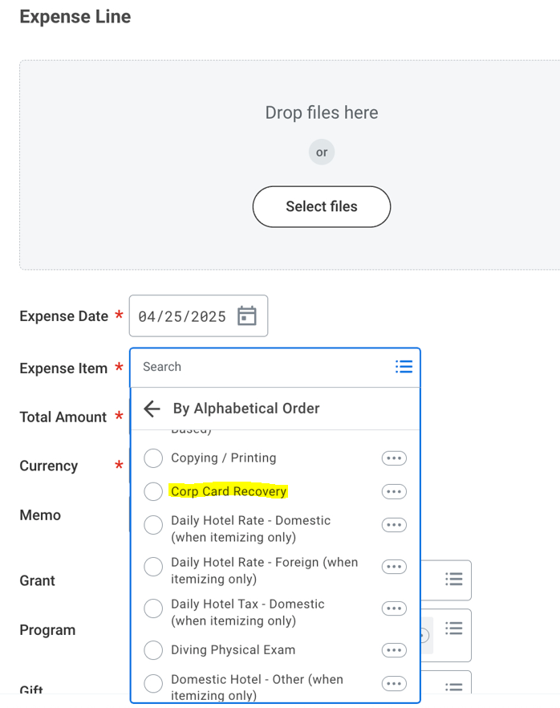

Note: If users have expense line items that are greater than 60 days aged, the messaging below will appear in Workday while completing the expense report:
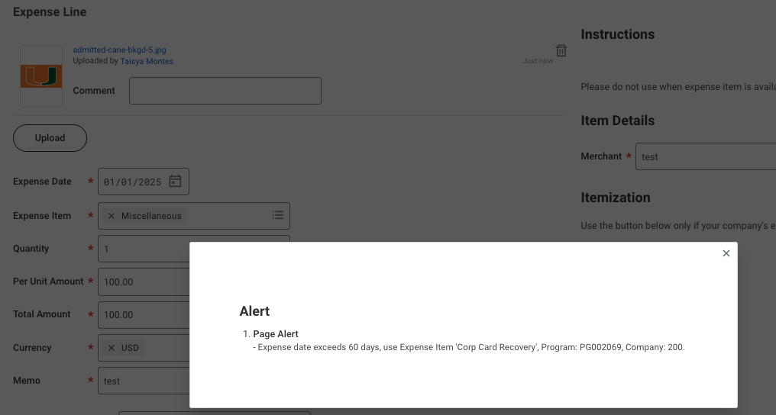
Step 2b: If the card holder received an exception for the expense over 60 days, that exception should be attached to the expense report and submitted using the appropriate category.
Step 3: The expense report will be routed to the disbursements team for review. If the report includes expense lines over 60 days, the disbursements team will confirm that Steps 2a-b were appropriately completed by the cardholder. If not, the expense report will be sent back to the cardholder to be corrected (Step 2).
Step 4: Expense report settles. Scheduled weekly reports (FIN-EXP-Corp Card Recovery Expense Reports and FIN-P2P-Corporate Card Recovery Procurement Card Transaction Verifications) runs from Workday showing the employee with expenses that charged account 2007 Procurement Card/Travel Card Recovery.
Step 5: Corporate card team to utilize report from Step 4 to complete EIB for payroll deduction. EIB needs to be submitted to Alicia Lopez in payroll by the following dates:
Monthly Payroll Cutoff: no later than the 16th of the month (i.e. May 16th submission for May 31st payroll)
Bi-weekly Payroll Cutoff: no later than 8 days prior to the bi-weekly pay date (i.e. May 22nd submission for May 30th payroll). See HR Pay Schedules for the current payroll schedule.
Step 6: Payroll deduction is completed, and personal expense amount is deducted from employee’s paycheck with the following limitations:
Total Expense to be Recouped | Number of Paycheck Deduction
< $500 | 1 paycheck deduction
Between $500 and $999 | 2 paycheck deductions
> $1,000 | 3 (or more) paycheck deductions

Accounting Impact:
Step 0a-b: Cardholder incurs charges on travel or procurement card. UM makes weekly payments to US Bank for transactions on the travel or procurement cards regardless of Workday expense report status for those transactions:
DB: 2102 UBS Travel Card Liability
CR: 2000 Accounts Payable
DB: 2000 Accounts Payable
CR: 1000 Cash
Step 2a: Card holder creates and submits expense report with transactions aged greater than 60 days. Therefore, the expenses are out of compliance with UM’s policy and deemed to be personal:
DB: 2007 Procurement Card/Travel Card Recovery
CR: 2104 Travel Card Clearing
Step 4: Expense report settles.
DB: 2104 Travel Card Clearing
CR: 2102 UBS Travel Card Liability
Step 6: Payroll deduction is completed for those transactions determined to be out of compliance and therefore personal expenses:
DB: 6005 Salaries and Wages
CR: 2007 Procurement Card/Travel Card Recovery

Summary of Accounting Transactions:
